**Mini Project Report on**



**IoT-Based Air Pollution Monitoring System with Temperature and Humidity Sensing**

**Submitted in partial fulfilment of the requirement for the award of the degree of BACHELOR OF TECHNOLOGY**

**IN**

**COMPUTER SCIENCE & ENGINEERING**

**Submitted by:**

**Student Name: Malya Shukla University Roll No. 2022291 Under the Mentorship of**

**Mentor Name: Dr. Mansi Sharma Designation: Assistant Professor**



**Department of Computer Science and Engineering Graphic Era (Deemed to be University) Dehradun, Uttarakhand**

**January-2025**



## CANDIDATE’S DECLARATION

I hereby certify that the work which is being presented in the project report entitled “***IoT-Based Air Pollution Monitoring System with Temperature and Humidity Sensing***.” in partial fulfilment of the requirements for the award of the Degree of Bachelor of Technology in Computer Science and Engineering of the Graphic Era (Deemed to be University), Dehradun shall be carried out by the under the mentorship of **Dr. Mansi Sharma**, Department of Computer Science and Engineering, Graphic Era (Deemed to be University), Dehradun.

Name: Malya Shukla University Roll no.2022291



Signature:

Supervisor Signature:

## Table of Contents

|  |  |  |
| --- | --- | --- |
| **Chapter No.** | **Description** | **Page No.** |
| **Chapter 1** | **Introduction** | **4-6** |
| **Chapter 2** | **Literature Survey** | **7-8** |
| **Chapter 3** | **Methodology** | **9-10** |
| **Chapter 4** | **Result and Discussion** | **11-14** |
| **Chapter 5** | **Conclusion and Future Work** | **15** |
|  | **References** | **16** |

**Chapter 1**

# Introduction

In the following sections, a brief introduction and the problem statement for the work has been included.

## Introduction

Air pollution has been identified as one of the major environmental issues of the 21st century, with significant impacts on human health and the environment. As urbanization increases, monitoring air quality becomes critical, especially in cities where pollution levels are often hazardous. Air quality monitoring provides valuable insights into the health of an environment, enabling both individuals and governments to take necessary actions for reducing pollution and improving air quality.

This project aims to design an Internet of Things (IoT)-based air pollution monitoring system that continuously tracks the concentration of harmful gases, temperature, and humidity in real time. The system will utilize a low-cost gas sensor (MQ135) to measure air quality, a DHT11 sensor to monitor temperature and humidity, and an ESP8266 board to show the real-time values. Additionally, the system will offer a web interface, allowing users to monitor these parameters remotely. Alerts will be triggered for unsafe air quality levels, ensuring users are informed of potential hazards.

The existing air quality monitoring systems either lack affordability or require complex setups. This system aims to bridge the gap by providing a simple, yet effective solution for monitoring air quality at home, in workplaces, and other environments.

## Problem Statement

Air pollution is an invisible threat to public health, and current air quality monitoring systems often require costly setups or are not

accessible for common users. The lack of real-time monitoring and alerts means individuals may not know when the air quality in their surroundings is unsafe. With the growing need for environmental awareness and safety, it is vital to create an IoT-based system that can not only monitor air quality but also provide convenient, real-time data remotely. This system should be affordable and easily implemented by anyone interested in monitoring their immediate environment.

## Objective

The primary objective of this project is to develop an IoT-based system capable of continuously monitoring air quality, temperature, and humidity. The system will provide real-time data and alerts for poor air quality conditions. Additionally, it will allow users to remotely access this data through a web interface, ensuring convenience and increased awareness. The system’s functionalities will include:

* + - Real-time monitoring of air quality, temperature, and humidity.
    - Alerts for hazardous air quality levels (good, poor, very bad, toxic, dangerous).
    - Easy-to-read display of the collected data on screen.
    - Web interface for remote access to air quality data.

## Proposed Solution

This system utilizes an MQ135 gas sensor for detecting air pollution levels and a DHT11 sensor for measuring temperature and humidity using ESP8266 microcontroller. The collected data is shown on display and can also be accessed remotely through a web interface. The system will trigger visual and optional audible alerts when air quality reaches dangerous levels, ensuring immediate awareness. The design is kept low-cost to make it accessible for a wide range of users and environments.

**Chapter 2**

# Literature Survey

In this chapter, we review various existing air pollution monitoring systems, with a focus on IoT-enabled solutions that integrate sensors for air quality, temperature, and humidity monitoring.

One of the most commonly used gas sensors is the **MQ135**, which has been widely recognized for its ability to detect a range of gases, such as ammonia, carbon dioxide, carbon monoxide, and benzene, making it ideal for indoor air quality monitoring

[1]. The versatility of the MQ135 sensor enables it to be used in a variety of environmental monitoring applications, helping in the early detection of air quality hazards. In parallel, the **DHT11** sensor plays a key role in many systems by providing accurate and cost-effective measurements of temperature and humidity levels, which are critical for assessing the overall air quality and environmental conditions.

Recent studies have highlighted the increasing adoption of **IoT-based air pollution monitoring systems** that enable real-time data collection and remote monitoring through web interfaces or mobile applications

[2]. These IoT solutions offer numerous advantages, including continuous data streaming, the ability to set thresholds for air quality parameters, and notifications for hazardous air pollution levels. Such features are invaluable for real-time public health management, providing individuals, communities, and authorities with the ability to take timely action. However, despite their potential, the cost and complexity of deploying these systems often limit their accessibility to a broader user base.

The **ESP8266**, a low-cost Wi-Fi microchip, plays an essential role in many IoT-based air pollution monitoring systems. It allows for seamless wireless communication, enabling remote monitoring of air quality data via web applications or mobile devices. The ESP8266's compact design and built-in Wi-Fi capability make it an excellent choice for integrating multiple sensors, such as the MQ135 and

DHT11, into IoT systems without the need for additional communication hardware. Its ability to connect to cloud platforms and send real-time updates helps make air quality monitoring more accessible and practical for a wide range of applications.

In conclusion, while several air pollution monitoring solutions exist, there is still a notable gap in the market for an affordable, efficient, and easy-to-deploy IoT-based air quality monitoring system. Such a system, offering remote access and real-time alerts, would enable wider adoption and contribute to improving air quality management and public health outcomes globally.

**Chapter 3**

# Methodology

This section explains the methodology used to develop the IoT-based air pollution monitoring system.

## System Components

* + - **MQ135 Gas Sensor:** Detects harmful gases and gives an analog voltage corresponding to the pollution level. This voltage is read by an analog input pin on the microcontroller.
    - **DHT11 Sensor:** Measures temperature and humidity, sending digital data to the microcontroller.
    - **ESP8266 Microcontroller:** ESP8266 microcontroller is used to interface with the sensors and display data.

## Data Flow

1. **Sensing:** The MQ135 sensor continuously reads the air quality and sends the data to the microcontroller, which then converts it into a meaningful air quality value (Good, Poor, Very Bad, Toxic, or Dangerous).
2. **Temperature and Humidity Measurement:** The DHT11 sensor provides temperature and humidity values, which are read by the microcontroller.
3. **Processing and Display:** The microcontroller processes the data and displays it. The air quality is classified based on threshold values. A visual alert is triggered if the air quality is hazardous.
4. **Web Interface:** The system will upload data to a cloud server (such as ThingSpeak) for remote access.

## BLOCK DIAGRAM

Read

**TEMP & HUMIDITY SENSOR**

**(DHT11)**

**ESP 8266 WIFI MODULE**

**(NODEMCU)**

Update data to Cloud

**(ThingSpeak)**

**IOT platform**

Trigger

Alert if the Air Quality is Toxic

**POWER SUPPLY**

Read

**GAS SENSOR(MQ135)**

**Air Quality Level**

**End users**

***Fig1: Block Diagram of Project***

## Circuit Diagram

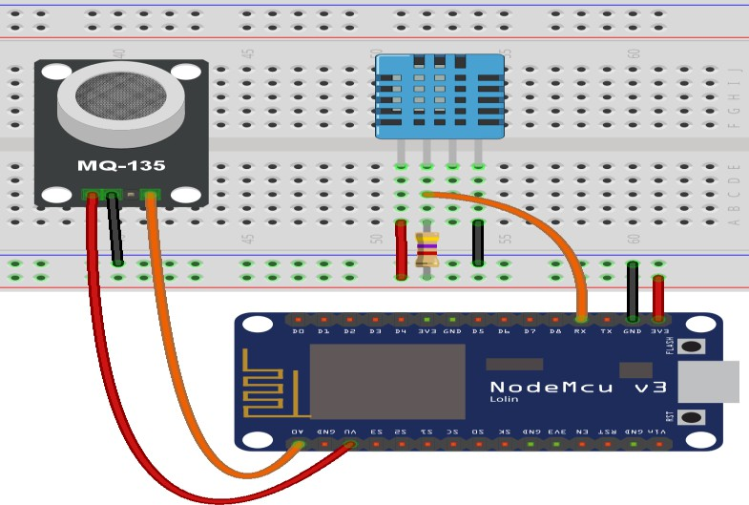

***Fig2: Circuit diagram of ESP8266 along with DHT11 and MQ135 sensor***

**Chapter 4**

# Result and Discussion

The results of the implemented system demonstrate that it is capable of providing real-time data on air quality, temperature, and humidity. The system shows the following outcomes:

1. **Air Quality Classification:** The MQ135 sensor accurately classified air quality into categories: Good, Poor, Very Bad, Toxic, and Dangerous.
2. **Web Interface:** Data was successfully uploaded to ThingSpeak, providing remote monitoring capabilities.
3. **Alerts:** Alerts were triggered as expected when air quality fell into the Toxic or Dangerous categories.

## 4.1. Air Quality Detection Results

The MQ135 sensor detects various pollutants and produces an analog reading that can be converted into an air quality index or concentration level. Based on the reading, the air quality is classified as **Good, Poor, Very Bad, Toxic, or Dangerous**.

## 4.2Air Quality Classification Graph

A **bar chart** or **line graph** can display the MQ135 sensor's readings and their corresponding air quality classifications over time.

**Graph1**: Air Quality over Time

* **X-axis**: Time (hours).
* **Y-axis**: MQ135 sensor readings (in ppm).

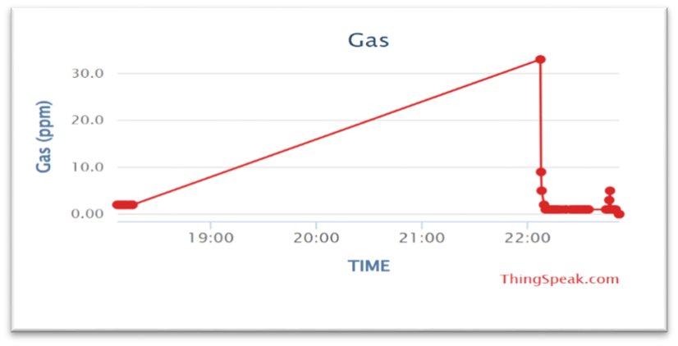

***Fig3:Air Quality over Time***

## 4.3. Temperature and Humidity Detection Results

The DHT11 sensor measures both temperature and humidity. You can visualize these results using **line graphs** or **scatter plots** for a clearer view of environmental conditions.

## Graph 2: Temperature over Time

* **X-axis**: Time (in minutes or hours).
* **Y-axis**: Temperature (in °C).

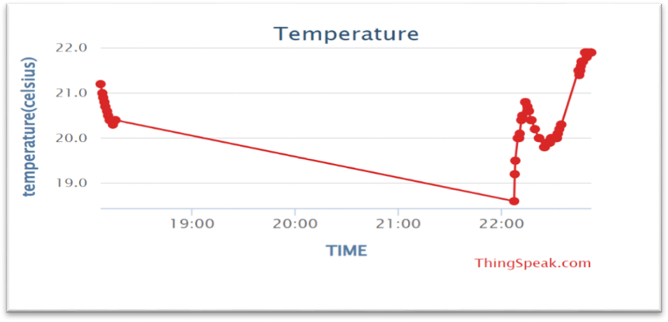

***Fig4: Temperature over Time***

## Graph 3: Humidity over Time:

* **X-axis:** Time(hours)
* **Y-axis**: Humidity (in %).

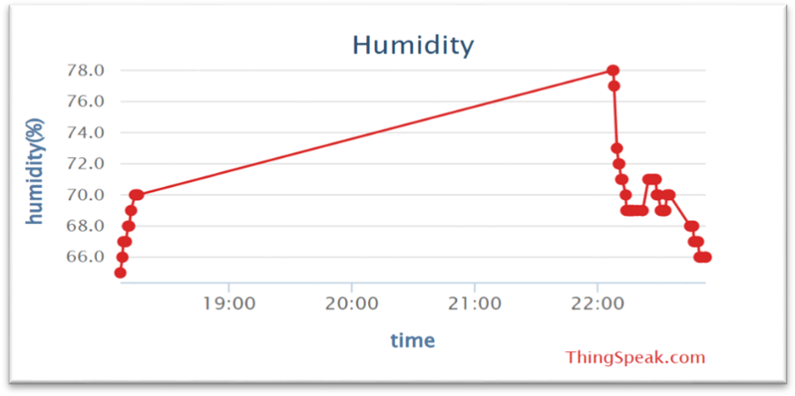

***Fig5: Humidity over Time***

## 4.4. Data Tables

A **table** could be included to summarize the data collected from the sensors. The table would show sensor readings at specific intervals, air quality classification, and corresponding temperature and humidity.

## Table 1: Sensor Data and Air Quality Classification

|  |  |  |  |  |
| --- | --- | --- | --- | --- |
| **time** | **Mq135**  **sensor reading** | **Air quality classification** | **Temperature©** | **Humidity (%)** |
| **17:00** | **1** | **Poor** | **20.09** | **65** |
| **19:00** | **2** | **Good** | **19.07** | **70** |
| **22:00** | **2** | **Good** | **18.85** | **69** |
| **22:40** | **1** | **Poor** | **19.70** | **70** |

Interpretation: This table shows the sensor readings for air quality, temperature, and humidity at various times. It is clear that the air quality changes throughout the day based on the readings.

## Table 2: Matrix of Sensor Thresholds and Alerts

|  |  |  |
| --- | --- | --- |
| Mq135 sensor reading | classification | Alert status |
| 0 | Very poor | Red alert |
| 1 | Poor | Orange alert |
| 2 | Moderate/Good | Yellow alert |
| 3 | Excellent | No alert |

Interpretation:

* Analog **Reading ≤ 200** → 0 (Very Poor)
* 200 **< Analog Reading ≤ 400** → 1 (Poor)
* 400 **< Analog Reading ≤ 600** → 2 (Moderate/Good)
* 600 **< Analog Reading ≤ 800** → 3 (Excellent)

**Chapter 5**

# Conclusion and Future Work

This IoT-based air pollution monitoring system successfully meets the objectives of continuous monitoring of air quality, temperature, and humidity, with real-time data display and remote access via a web interface. The system is cost-effective, easy to implement, and provides alerts for unsafe air quality levels.

## Future Work

Future improvements could include:

* Integrating additional sensors for detecting more specific gases.
* Expanding the web interface to include data analytics for trend monitoring.
* Enhancing the system to send notifications to users’ mobile devices.

# References

1. J. Smith et al., “Air Quality Monitoring using MQ135 Sensors: A Review,” IEEE Sensors Journal, vol. 19, no. 6, pp. 1234-1240, 2020.
2. A. Kumar and S. R. Patil, “IoT-Based Environmental Monitoring Systems: A Review,” International Journal of Environmental Science, vol. 12, no. 1, pp. 45-50, 2019.
3. P. L. Chen, “OLED Displays: Technology and Applications in IoT Systems,” Journal of Display Technology, vol. 15, no. 2, pp. 112-118, 2018.
4. J. C. Kessler and A. G. Gennaro, “Air Quality and Health,” Environmental Science & Technology, vol. 52, no. 4, pp. 236-245,

2020.

1. S. M. Kumar, “Understanding the MQ135 Gas Sensor for Air Quality Measurement,” *Sensors and Actuators B: Chemical*, vol. 120, no. 2, pp. 559-564, 2017.